***The pie chart gives information on the proportion of carbohydrates, protein and fat in three different diets.***

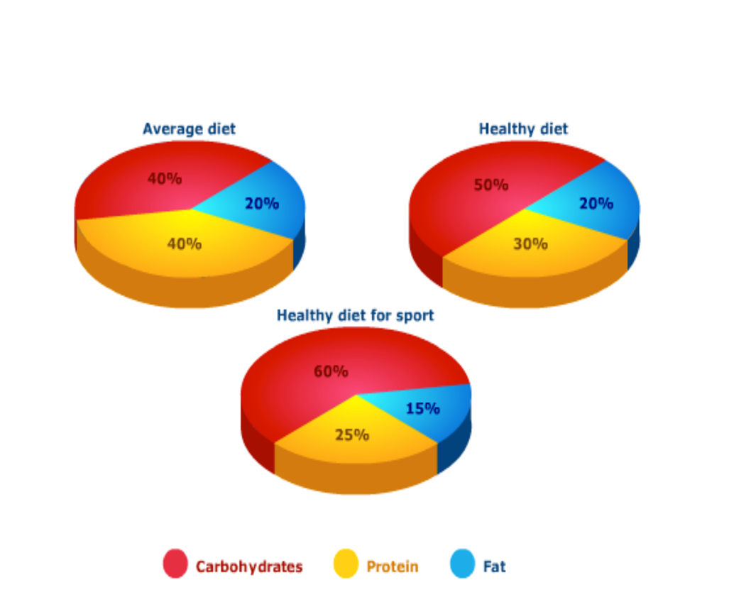

Given is the chart comparing the percentage of nutrients in three different diets, namely average diet, healthy diet and athletic diet.

⇒ Cách chia bố cục 2 đoạn thân bài & overall như này ổn rồi nhé, xem thêm hướng dẫn phía dưới

In general, carbohydrates are required the most in all diets while the opposite is true for fat. It contributes to the diets for a small amount.

A detailed look at the charts reveals the percentage of carbohydrates in a vigorous diet for sport is 60%. Moreover, the proportion of them in the diet for normal citizens amounts to 40%, which is 10% lower than that in a healthy diet. The second largest compound is protein, which in the average diet comprises 40% compared to 30% in the healthful one. Besides, consuming less of it are individuals following the vigorous diet of athletes, the contribution of protein is a relative amount of 25%.

In addition, the percentage of fat in the diet of normal people and in the healthy diet is the same, at 20%. However, that figure drops to 15% in the diet of sportspeople.

[IELTS TUTOR](https://www.ieltstutor.me/blog/sua-de-thi-ielts-writing-22-8-2020) lưu ý:

* + Overall:
    - Sportspeople require a diet comprising a significantly higher proportion of carbohydrates than an average diet or a healthy diet. >> IELTS TUTOR hướng dẫn [Cách dùng động từ"comprise"tiếng anh](https://www.ieltsdanang.vn/blog/cach-dung-dong-tu-comprise-tieng-anh)
    - Carbohydrates accounted for the majority of contributions among the three diets
  + Body 1: Viết về Carbonhydrares + Protein
    - Carbohydrates make up 60% of the healthy diet for sport, 10% higher than the proportion of carbohydrates in a normal healthy diet, and 20% more than the proportion in an average diet.
    - People who eat an average diet consume a greater relative amount of protein (40%) than those who eat a healthy diet (30%) and sportspeople (25%). >> IELTS TUTOR hướng dẫn [Cách dùng động từ"include"tiếng anh](https://www.ieltsdanang.vn/blog/cach-dung-dong-tu-include-tieng-anh)
  + Body 2: Viết về Fat
    - Fat constitutes exactly one fifth of both the average diet and the healthy diet, but the figure drops to only 15% for the healthy sports diet.
* IELTS TUTOR gợi ý cách bố cục khác:
  + Body 1: Viết về average diet + Healthy diet
  + Body 2: Viết về healthy diet for sport